Randomized selection

The problem: I-th order statistic (ie I-th smallest element of input array). For example the median is the (n+1)/2 order statistic for odd array.

We can easily resolve this by reducing it to merge Sort. This is called problem reduction.

If we want a better running time than O(n), we will use a modified version of Quicksort. Remember that by partitioning an array, the pivot ends up in its rightful position. So if we partition an array of length ten looking for the fifth order statistic and the pivot ends up in position 3, we only have to look for the second order statistic on the sub array right of the pivot.

In the best case pivot, the running time is T(n)< t(n/2) + O(n) (there is only one recursive call) and, according to master method, the running time is O(n^d), in this case O(n)
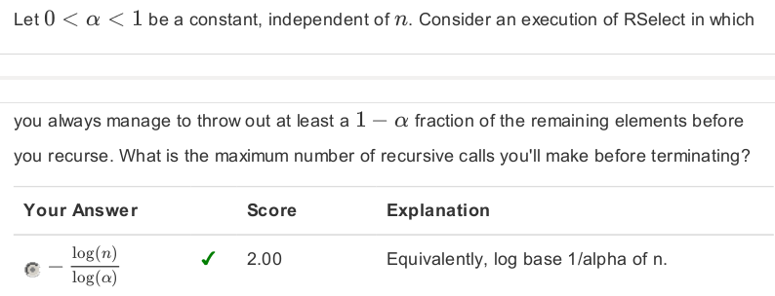

Graph Cuts and Minimum Selection

Vertices == Nodes aka points

Edges denoted I, are pairs of vertices aka lines

If there are arrows, aka if the graph is directed, the first vertex is where the arrow beggins (the tail), the second vortex is where the arrow is pointing

The Web is often considered a directed graph.

A cut of a graph is a partition of that graph into two non empty sets A and B

A crossing edge is an edge which goes from one set to the other, ie where the tail and the end vertices of that edge are in different sets.

Minimum Cut Problem

Compute a cut with the minimal number of crossing edges. A popular application is identifying weaknesses in networks, or how to identify closely knit groups of people in social networks.

Graph Representations

The number of edges in a graph of n vertices is between

In other words, m is Omega(n) and O(n^2)

Adjacency Matrix the values in i,j represent the relationship between the vertices i and j (ex 1 if I→j and -1 if j→i). Teh size is n^2, in other words, the space is theta(n^2), this is good for dense graphs but not so much when there are not a lot of edges involved compared to the number of vertices.

Adjacency List

Random Contraction Algorithm

While there are more than two vertices, we choses successively edges (u,v) at random
Merge u and v into a single vertex
Remove self loops (aka edge contraction)
return cut represented by two final vertices. In the end we have two vertices with a number of edges connecting them; those are the two final sets with the minimal number of crossing edges

What is the probability of success?
Let k be the number of edges crossing A and B (noted F). Success is defined by the event that the cut we obtain from the algorithm produces a predetermined outcome of sets A and B. This success will occur only, and only if none of the F edges are contracted.
Before going further, we observe that since k is the number of crossing edges in the optimal solution, each initial vertex is of degree at least k (means it is connected to at least k other vertices).
Therefore, since the number of edges in the whole graph is m, we have
m >= (n*k)/2

We want to express m with n, because it is easier to follow up as the vertices get fusionned. In the end, the probability of success is >= 1/n^2, which is low. How can we boost this probability?

We will boost the prob of success by running Repeated trials, and remember the minimal cut.

If we note Ti the probability that the I-th try fails, in order to fail I times to find the minimum cut, every one of these tries must fail: that's <=
(1-1/n^2)^i

Counting minimum cut

There are often more than one possible minimum cuts. For egz a tree with n vertices has n-1 minimal cuts because each node is linked to max 2 other nodes

How to count the largest number of min cuts?
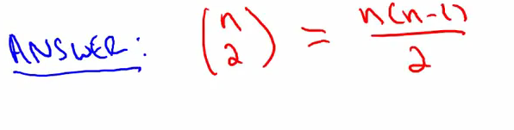
Algorithmic implementation

We start by converting the adjacency list into a list of lists where the first sublist is the vertex, the second list is the vertices it is connected to

max flow/min cut theorem
In optimization theory, the max-flow min-cut theorem states that in a flow network, the maximum amount of flow passing from the source to the sink is equal to the minimum capacity that, when removed in a specific way from the network, causes the situation that no flow can pass from the source to the sink.

